LOCAL PENSIONS PARTNERSHIP INVESTMENTS LIMITED
Lancashire County Pension Fund
Pension Fund Committee | 29 March 2019
Responsible Investment Report

Title of Paper | Quarterly Report on Responsible Investment (2018 Q4)
Lead Officer: | Frances Deakin  Head of Responsible Investment  Local Pensions Partnership Investments Ltd  frances.deakin@localpensionspartnership.org.uk
Appendices | None

- Executive Summary

This report provides members of the Pension Fund Committee of Lancashire County Pension Fund (LCPF) with a quarterly update on Responsible Investment (RI) matters.

- Introduction

The Fund's approach to RI is articulated within an Investment Strategy Statement (ISS) which confirms that the objective of RI is to decrease investor risk, improve risk-adjusted returns and assist the Fund's adherence to the UK Stewardship Code. LCPF’s ISS is supplemented by a Responsible Investment Policy which explains that the Fund's preferred approach to RI encompasses four main areas of activity:
- Voting Globally
- Engagement through Partnerships
- Shareholder Litigation
- Active Investing

Responsibility for the practical implementation of the Fund's approach to RI is devolved to Local Pensions Partnership Investments Ltd (LPPI) as LCPF's provider of investment management services. The report which follows provides the Committee with an update on RI activity during the period 1 October to 31 December 2018 plus insights on current and emerging issues.

- Voting Globally

Through its investment in the LPPI Global Equities Fund (GEF) LCPF owns units in a pooled fund which invests in listed companies globally. Investors in the GEF delegate the control and exercise of shareholder voting to LPPI. This reflects that clients owning units in the GEF are beneficial owners in common but do not directly own shares in underlying companies.

LPPI exercise shareholder voting rights for the GEF centrally rather than delegating voting to individual asset managers and take account of voting recommendations from an external provider of proxy voting and governance research (ISS) in accordance a Sustainability Voting Policy designed to ensure the consideration of ESG factors within analysis. LPPI review voting recommendations and take the final decision on all voting.

In the fourth quarter of 2018 shareholder voting headlines for the GEF were as follows:

LPPI Global Equities Fund (GEF)

Total company meetings taking place | 63
Total resolutions  (management and shareholder proposals) | 609
Total company proposals in the period | 599
Total shareholder proposals in the period | 10

Company Proposals
Voting Supported Management | 560 | 93%
Voting Opposed Management | 39 | 7%

Shareholder Proposals
Shareholder proposals supported by LPPI | 6 | 60%
Votes against shareholder proposals | 4 | 40%

The following table summarises resolutions by type and indicates where opposition voting was concentrated in Q4.

 | Proposals
 | For | Against | Withhold | Total
Anti-takeover Related | 2 |  |  | 2
Capitalization | 96 | 2 |  | 98
Director Related | 258 | 15 | 5 | 278
Non-Salary Compensation | 80 | 13 |  | 93
Preferred/Bondholder | 1 | 2 |  | 3
Reorg. and Mergers | 60 |  |  | 60
Routine/Business | 63 | 2 |  | 65
SH-Compensation | 1 | 1 |  | 2
SH-Director Related |  | 1 |  | 1
SH-Soc./Human Rights | 1 |  |  | 1
SH-Other/Miscellaneous |  | 3 |  | 3
SH-Routine/Business | 1 | 2 |  | 3
Total | 563 | 41 | 5 | 609

LPPI voted against management proposals in 39 instances.
This included opposing management nominations in the election / re-election of 9 directors. Voting reflected concerns with the composition and independence of company boards as a whole, and with the independence of individual Board members. Companies involved included FirstRand (Diversified Financial Services) Harvey Norman (General Merchandise Stores) and Alibaba (Internet & Direct Marketing Retail).

Management proposals on compensation arrangements prompted 13 opposition votes. These mainly reflected an inadequate disclosure of information around performance conditions and the basis of sub-components within compensation calculations and questions about the alignment of incentives through the use of appropriate vesting periods.

Most Australian companies hold their AGMs in October and November each year (Q4). The Australian Corporations Act requires listed companies to include an audited remuneration report in the annual report and to put their remuneration report to a shareholder vote at the AGM.

At National Australia Bank LPPI voted against the remuneration report because a new Variable Reward (VR) plan appeared excessively short-term (based on a one-year assessment of performance) and the quantum of rewards achievable had not been adjusted to appropriately reflect the higher certainty of receiving them under the revised approach. (Result: 88% against).

At Telstra (Australia: Integrated Telecommunication Services) LPPI voted against the remuneration report due to the company not having adequately addressed shareholder concerns raised in the previous year regarding its remuneration practices. Issues included misalignment between executive pay and company performance which continue despite the Board reporting the use of discretion to reduce outcomes on the basis of poor company performance and declining share price. Sizable cash rights to two departing executives and an increase in the CEO's fixed remuneration from a level already higher than median were amongst the problems identified. (Result: 62% against).

At Oracle Corp (USA: Systems Software) LPPI opposed Management on an advisory vote on executive officers' compensation. This reflects that the board has not been sufficiently responsive to shareholder concerns expressed through six consecutive years of failed say-on-pay votes. The continuation of front-loaded equity awards will continue to translate into high pay (relative to peers) and the award structure limits the ability to adjust pay over the upcoming five years. (Result: 46% against).

LPPI supported 6 shareholder proposals across 3 company meetings in Q4, on what are now familiar themes related to improved governance and greater transparency.
Four of the six resolutions were at the Oracle AGM where the requirements shareholder proposals made of the company were as follows:

- Provide a Report on Gender Pay Gap (Result: 39% support)
- Provide a Report on Political Contributions (Result: 21% support)
- Provide a Report on Lobbying Payments and Policy (Result: 27% support)
- Adopt a Policy Requiring the Chair of the Board to be an Independent Member of the Board (Result: 30% support)

At Woolworth Group (Australia: Food & Staples Retailer) the AGM was due to receive a shareholder resolution on human rights reporting. The proposal asked the company to report on its process for identifying and addressing adverse human rights impacts in its operations and its supply chains. While the company has made progress in its policy regarding its apparel supply chain, it has made more limited progress in policy (and implementation) regarding its agricultural supply chain, despite reported controversies. LPPI supported a proposal which seeks to strengthen Woolworths' commitment to human rights, as well as improve its oversight mechanisms, to help safeguard the company's reputation and long-term shareholder value.

The proposer (Australian Centre for Corporate Responsibility) has reported that proxy votes cast ahead of the meeting were signalling 14% support but, after committing to work with ACCR, the resolution was withdrawn by the company and was not put to a vote at the AGM.

Members can view details of shareholder voting for all meetings via the LPP website where quarterly reports for the GEF are made publicly available.
https://www.localpensionspartnership.org.uk/what-we-do/investment-management

- Engagement through Partnerships

LPPI regularly participates in collaborations which aim to make progress on commonly held issues by co-ordinating the efforts of multiple investors. Key partners include the Local Authority Pension Fund Forum (LAPFF) the Pensions and Lifetime Savings Association (PLSA) the Principles of Responsible Investment (PRI) the Institutional Investor Group on Climate Change (IIGCC) the LGPS Cross Pool RI Group, and the UK Pension Scheme RI Roundtable.

LAPFF

LAPFF has long been LCPF's preferred engagement partner. It has been a long-term member of the Forum and the Head of Fund and Chair of the Pension Fund Committee both currently sit on the LAPFF Executive.

LAPFF’s engagement programme reflects the Forum's assessment of key priorities arising from across the collective equity holdings of LAPFF members. The Workplan for 2019 is due to be agreed by members at the next LAPFF Business Meeting (17 April 2019) after feedback is received from member funds as part of a consultation process currently underway.

On a quarterly basis LAPFF provide a summary of the engagement activities undertaken on behalf of member funds which is available from the LAPFF website. http://www.lapfforum.org/publications/qrtly-engagement-reports/

Quantified across thematic topics, engagement activity by LAPFF in Q4 was as follows:
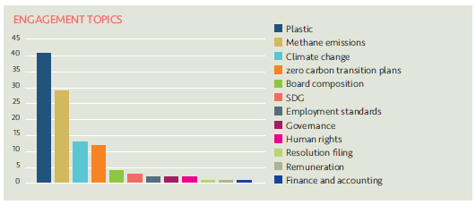
The 95 companies engaged with and the topics covered by LAPFF in Q4 were as follows:
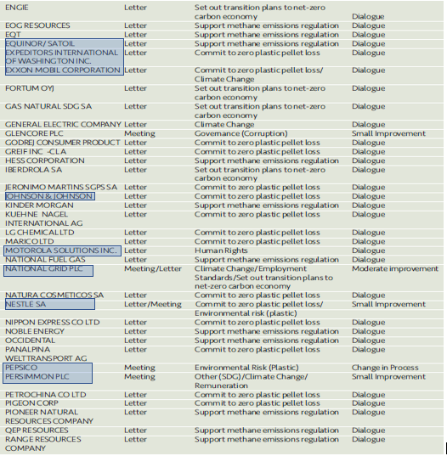
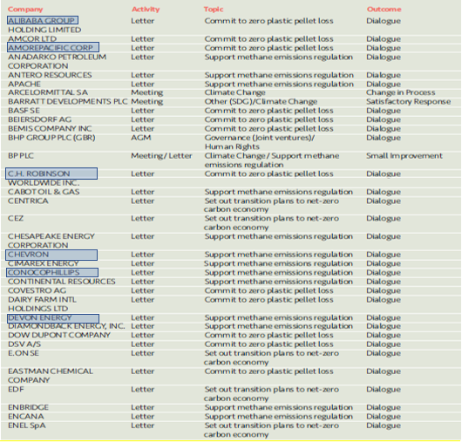

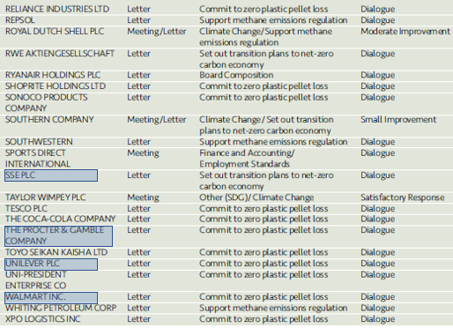

19 companies (highlighted above in blue) are held within the LPPI Global Equities Fund in which LCPF owns units.

30 of the 95 engagements relate to a letter sent to US oil & gas companies as part of an investor collaboration seeking support for continued methane emissions regulation by the Environmental Protection Agency (EPA). Firms have been urged to engage constructively with any further process of regulation by a mainly US-based investor group. Further details of the initiative (including membership) are available from the following link. https://www.iccr.org/investors-see-proposed-rollback-methane-regs-threat-long-term-viability-oil-gas-sector

LPPI has engaged with companies via a range of investor collaborations in Q4.
Examples include the following activities and initiatives.

Institutional Investor Group on Climate Change (IIGCC)
As part of an initiative co-ordinating 95 participating investors, in December 2018 LPP was a signatory to a letter to European power companies calling on them to demonstrate they are ‘fit for a clean energy future’.

The power sector accounts for around a quarter of all global emissions and progress here is also critical to the successful decarbonisation of other key sectors. Signatories to the letter include some of the largest institutional investors and asset managers in Europe (and in some instances globally). 20 of the 95 total signatories individually have over $200 billion in assets under their management. LPP’s participation is a clear example of engagement effort being focussed to where it is likely to have maximum influence.

The investor letter asks firms to demonstrate they are implementing business strategies aligned with the goals of the Paris Agreement and sets expectations for corporate planning for a future in a net-zero carbon economy. The collaboration was facilitated by IIGCC and details of the letter appear within the IIGCC Press Release available here.

Climate Action 100+
In December 2018 LPPI submitted papers to co-file its first shareholder proposal at a company meeting. This was at Exxon Mobil as part of an initiative arising out of our participation in Climate Action 100+.

Filing a proposal in the US is a formal process requiring a range of paperwork to be submitted including proof of qualifying shareholdings via a letter from a custodian bank. LPPI worked with (and gained advice from) a network of investors in Europe and the US to achieve the tight deadline to co-file the proposal which it is intended will arise at Exxon’s 2019 AGM in May.

The proposal asks the company to set short, medium, and long-term targets for emissions reductions in line with the Paris Agreement. The lead filer is the New York State Comptroller (as Trustee for the New York State Common Retirement Fund) with support from the Church Commissioners for England as lead co-filer. A press release (by the Church Commissioners) providing further information on the proposal is available here. LPP is one of 30+ investors who have co-ordinated to co-file.

The ability of Exxon shareholders (including LPPI’s Global Equities Fund) to consider and vote on the resolution at the AGM depends on the outcome of a process overseen by the Securities and Exchange Commission under which Exxon is seeking not to table the proposal. As dialogue between the proponents and the SEC continues, LPP is maintaining contact with the lead parties and has agreed to signal support for the proposal (as a signatory to ancillary letters being co-ordinated by collaborating investor groups).

Shareholder Litigation

LPPI employ Institutional Protection Services (IPS) as an external provider of litigation monitoring services to ensure shareholder litigation cases affecting securities owned by the GEF are known about, claims are filed in a timely way and progress is monitored and followed up with Claims Administrators. In addition, IPS monitor cases relating to shares held by LCPF in the period before the Fund pooled its listed equity investments from November 2016. Litigation can arise quite some time after shares have been sold and monitoring new cases and referring back to historic holdings records to establish rights of ownership is an ongoing task.

IPS provide LPPI with monitoring information on a quarterly basis detailing the number of cases investigated. The monitoring report for Q4 2018 confirms that whilst no new potential cases were identified where the Fund might have an entitlement to join a class action, there were 5 existing cases where eligibility has been confirmed and a claim will be filed and 2 which have been discounted following further analysis.

- Active Investing

The LCPF Responsible Investment Policy describes active investing as the search for sustainable investments which meet LCPF’s requirements for strong returns combined with best practice in ESG and corporate governance. The Fund has not set allocations for investments within specific sectors but favours sustainable investments with positive social characteristics and has identified climate change as a particular thematic priority.

Recent analysis of LPPI’s Global Equities Fund (GEF) has produced additional insight into an important aspect of the sustainability of LCPF’s portfolio over the long term (its emissions profile) and has identified a good news story for investors in the GEF.

Portfolio Emissions Intensity

LPPI’s new RI Policy Annex on Climate Change includes a commitment to review the alignment of the GEF with a 2°c pathway on an annual basis. This is in order to reference the emissions position relative to the goals of the Paris Agreement.

To fulfil the new commitment, portfolio analysis has recently been produced by an external data provider (Engaged Tracking) whose report presents the outcome of comparing the GEF’s emissions with the levels needed to achieve the Paris Agreement goal of 2°c. The comparison has revealed a very positive position for the GEF (and by extension for funds holding units in the GEF).

Analysis of the GEF’s alignment with the Paris target was based on forecasting the total emissions the global economy would have if it had the same composition as the GEF and comparing this position with the global emissions expected under the scenarios that lead to global average temperature increases of 2.7°c, 2°c and 1.75°c. Positions and pathways are then expressed as proportions of global emissions in 2014.

LPPI Global Equities Fund - Alignment with Decarbonisation Pathways
(Holdings as at 31.12.18)

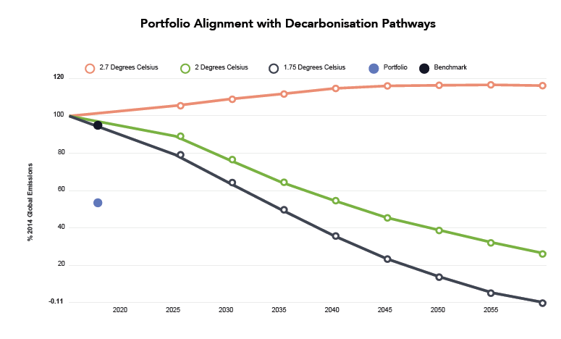

Benchmark

GEF

The GEF is shown to be positively aligned with (have a lower emissions intensity than) the pathways for achieving both 2°c and 1.75°c targets (based on holdings at 31 December 2018).
There is a notable gap between the emissions of the GEF and of the benchmark (MSCI All Countries World Index) at the snapshot date which speaks to the higher emissions profile associated with investing passively in line with MSCI ACWI. The GEF has significantly lower emissions as a result of investment decisions by active portfolio managers who are incorporating material Environmental, Social and Governance considerations (including climate change) into their evaluation of risk adjusted returns.

LPP will continue to work with Engaged Tracking to better understand the GEF’s emissions profile and to identify the sectors and companies which are making the largest contributions to total emissions.

Other Insights
- FCA Discussion Paper on Climate Change and Green Finance

LPP has recently responded to a discussion paper on Climate Change and Green Finance from the Financial Conduct Authority (FCA) the UK regulator for firms that provide financial products and services. As an asset manager, LPPI is authorised and regulated by the FCA.
The discussion paper describes proposals for placing additional focus on the risks and opportunities posed by climate change. This reflects the FCA's recognition that climate change and the global transition to a low carbon economy are likely to have a significant impact on financial markets and products and will hold a particular risk for the financial performance of pension funds due to their long investment horizons.
As a Responsible Investor LPPI is already working to evaluate the investment risks and opportunities climate change poses for client pension funds. Our responses to the twelve questions posed by the FCA discussion paper reflected the insights we have gained so far and urged the regulator to align any additional future requirements with initiatives already underway within the investment community. For example, we highlighted the Taskforce on Climate-related Financial Disclosure (TCFD) which is focused on encouraging better information disclosure from companies on how they are managing the risks and planning for the future impact of climate change on their business.

LPP’s full response to the FCA discussion paper is available here.
- Consultation: Proposed Revision to the UK Stewardship Code

On 30 January 2019, the Financial Reporting Council launched a consultation on an updated 2019 UK Stewardship Code.

Effective stewardship is an important part of institutional investors' responsibilities to their clients and the draft 2019 Code is an integral part of the UK's overall corporate governance framework. It significantly raises the standard expected from institutional investors and aims to create a market for stewardship driven by a demand from asset owners and beneficiaries for better quality information about how asset managers and service providers fulfil their responsibilities. Those who become signatories will be making a serious commitment to maintaining and improving the quality and integrity of UK financial markets. The FRC will be devoting more resource to evaluating the quality of disclosure of both policies and activities.

LGPS pension funds are required to be signatories to the UK Stewardship Code and to comply with (and disclose on how they comply with) its requirements. The UK Stewardship Code was last updated in 2012 and all new requirements introduced as a result of a revised Code will fall to be addressed by LCPF going forward.

The FRC’s consultation is open until 29 March 2019. It is intended that a 2019 Stewardship Code will be published on 16th July 2019 and that its requirements will come into effect from that point.

Full details of the consultation and the proposed revised code are available here.

